Intelligent Train Engines
Introduction:
by
Ashutosh M Bhatt
a_m_bhatt@indiatimes.com
www.multyremotes.com
We know that the railway network of India is the biggest in south Asia and perhaps the most complicated in all over the world. There are so many different types of trains local, fast, super fast, passenger, goods.... etc. and their so many multiple routs. Although the time table is perfect it is not at all possible to maintain it. And that’s why the train accidents are becoming more and more usual. So why not we add a kind of intelligence to the train engines itself so that it tries to avoid accidents.
The idea is whenever any engine observes a red signal on its track it will start decreasing its speed gradually and stops automatically at some distance from the signal pole. After then when it gets green signal the driver can manually start the train and go on. In the mean time when train has not stopped yet and a red signal becomes green then it crosses the signal pole with low speed and then driver can slowly increase the speed.
So now before the driver observes the red signal the engine itself observes it and automatically starts decreasing speed and then stops. The driver can feel relax in driving because he doesn’t have to take care about red signal. Even if he forgets to take any action on red signal then also we can avoid accidents by the implementation of this idea.
General description:
What we have to do is we have to attach a transmitter with signal pole which will start transmitting signals only when the red light is on. If there is green light no transmission. The engine has a receiver which catches these transmitted signals and takes desire actions.
Both the transmitter and receiver are of RF type with minimum range of 2 Km. so that train can get enough time to decrease its speed and stop before the signal pole with minimum swapping distance of 100-200 mt.
Here in our project we have used IR transmitter and receiver instead of RF for demo purpose. But same idea can be easily implemented with RF also with a little more cost.
Lets first discuss the demonstration model.
Demonstration Model:
The train engine runs on 24V DC motor so that we can easily vary its speed by varying applied voltage. The switching voltage is applied in step of 18 V, 15 V, 12 V and 9 V (min speed). The 230 VAC is step-down to 24 VAC by 12-0-12, 2 Ampere step down transformer. As shown in figure this 24 VAC line runs parallel with track at the top of the train. Movable tapping are taken from this line and fed to the internal circuit of engine. These tapping slides as the train runs on the track and give continuous supply to circuit. The IR sensor is placed at the top of the engine, senses the signals transmitted by IR transmitter attached to signal pole. Train track is straight and 20 ft long. Signal pole is placed at the end of track and train starts from farther end.
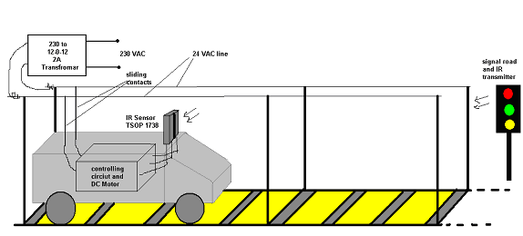

The project is divided in two parts 1) transmitter 2) receiver
The transmitter is housed in signal pole and it is activated only when red light is ON.
The receiver is housed in engine which senses the IR signals and takes suitable action.
Signal Pole IR Transmitter:-
The figure shows the schematic diagram of IR transmitter.
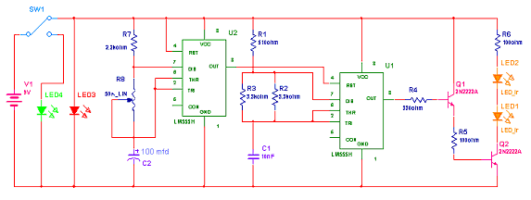
The heart of the circuit is IC555. The main component of the circuit is only IC555.
Connections:
Both ICs are connected in astable mode. The frequency of U2 is 0.5 Hz and U1 is 38 KHz. This is decided by RC components connected with it. The output of U2 is connected with reset pin (4) of U1. Thus the output of U2 controls the operation of U1 means it will switch on or off the output of U1. The output of U1 is fed to two IR LEDs through Darlington pair made up of Q1, Q2 and R5. The 9V DC battery is connected with circuit through SPDT switch SW1 as shown.
Operation:
As shown in figure when SW1 is in position as shown the transmitter is On and also the red LED is also ON. When switch changes its position the red LED and transmitter is off and only green LED will on. When the circuit is energized U2 will start generating high pulse at every 1 sec. as this pulse is fed to reset pin of U1 it will generate 38 KHz square wave and give it to IR leds. IR leds will generate IR beam of 38 KHz for the same time. Thus after every one second the IR beam of 38 KHz is generated for one second only. This cycle repeats till the red light is on.
Note: The range of this transmitter is limited to 10 ft only.
89C51 based IR receiver for Engine:
The IR receiver circuit housed in engine is as shown below.
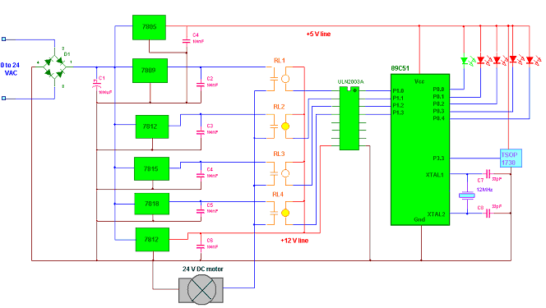
The main components of the circuit are IR sensor TSOP 1738, microcontroller 89C51, current driver chip ULN2003A and all voltage regulator ICs (78XX series).
Connections:
- 24 VAC is rectified by diode bridge D1 and filtered through C1 and given to all the regulated ICs as input.
- The output of 7805 is connected to 89C51 and TSOP and also to all the LEDs.
- Output of 7812 (last one) is connected to common coil terminal and to ULN
- The outputs of middle four regulated ICs are connected to DC motor through relay contacts.
- Output of TSOP is connected with pin P3.3 (INT1) of microcontroller
- All five leds are connected with port P0 as shown
- Input of ULN is connected with Port 1 pins P1.0-P1.3, and outputs are connected with second terminal of relay coil.
Operation:
- TSOP will detect the 38 KHz IR beam and gives the interrupt to 89C51.
- 89C51 will indicate the interrupt event on first (green) LED and energizes only one particular relay through ULN chip.
- When any of the four relay get energized the motor will get supply from it and it will start running
- As voltage is less it will run with less speed
- So now its the function of microcontroller to receive signal from IR sensor, decrease the speed of train gradually in four steps and then stop it. And this is done by software embedded in to 89C51.
How the project works?
- Initially when you switch on the supply 89C51 will switch all the relays RL1- RL4 one by one. So motor will get 9-12-15-18 V supply in steps and gradually increases its speed reaches max speed indicated by first red LED (P0.0).
- Now if the signal is green then train will cross the pole with same pole
- But if signal becomes red in between then IR sensor will detect IR beam and interrupts the 89C51
- Getting first interrupt 89C51 will switch off RL4 and switch on RL3 so now motor will get 15 V supply and its speed will be decreased. That’s indicated by second red LED (P0.1)
- Now 89C51 will wait for some time (2 to 3 sec) and train goes on with same speed. Again if still red signal is on 89C51 will be interrupted and this time it will switch on RL2. so now motor gets 12V supply and again its speed will be decreased indicated by third red LED (P0.2)
- The same procedure repeats if 89C51 is interrupted third times. Now motor runs at min speed (9 V) indicated by fourth red LED (P0.3)
- After same delay on receiving fourth interrupt all the relays will be switched off and motor is now stop so the train is also stopped. This is indicated by green LED.
- After this interrupts will be disabled. So now when red signal becomes green driver must reset the controller to start the train again.
The complete pseudo code with necessary comments is as given
org 00h
mov r0,#01h ; initialize the counter to count no. of interrupts
sjmp over ; jump above the interrupt subroutine
org 0013h ; interrupt 1 subroutine location
mov ie,#00h ; disable interrupt first
clr p0.0 ; interrupt indication on green led
inc r0 ; increment counter
acall delay ; call 0.1 sec delay
setb p0.0 ; reset green led
cjne r0,#02h,nxt2 ;if counter is 2 then decrease speed be one step (15 V)
mov p0,#0fbh
mov p1,#04h ; give indication on second red led
sjmp out
nxt2: cjne r0,#03h,nxt3 ; if counter is 3 then decrease speed be two step (12 V)
mov p0,#0f7h
mov p1,#02h ; give indication on third red led
sjmp out
nxt3: cjne r0,#04h,nxt4 ; if counter is 4 then decrease speed be three step (9 V)
mov p0,#0efh
mov p1,#01h ; give indication on fourth red led
sjmp out
nxt4: cjne r0,#05h,out ; if counter is 5 then stop the train
mov p0,#0feh
mov p1,#00h ; indicate it by green led.
out: acall dely ; call 2 sec delay every time when speed is changed
mov ie,#84h ; enable interrupt again
reti ; return from interrupt
over:mov p1,#01h ; main program starts from here starts train with min speed
acall dely ; and gradually increase it to max in four step
mov p1,#02h ; with 2 sec delay in between
acall dely
mov p1,#04h
acall dely
mov p1,#08h
mov p0,#0fdh
mov ie,#84h ; enable the interrupt
here: sjmp here ; continue loop
delay:
mov r6,#64h ; 0.1 sec delay
lop2:mov r5,#0FAh
lop1:nop
nop
djnz r5,lop1
djnz r6,lop2
ret
dely:
mov r7,#15h ; 2 sec delay
lop5:mov r6,#64h
lop4:mov r5,#0FAh
lop3:nop
nop
djnz r5,lop3
djnz r6,lop4
djnz r7,lop5
ret
end

